AUTOMATIC HELMET AND LICENSE PLATE RECOGNITION USING YOLOV5 WITH INSTANT E-CHALLAN INTIMATOR

|  |  |  |  |
| --- | --- | --- | --- |
| Siva Nageshwarao | Y.Saketh Kumar | B.Ranga Sai Karthik | K.Manikya Rao |
| Department of Computer Science and Engineering | Department of Computer Science and Engineering | Department of Computer Science and Engineering | Department of Computer Science and Engineering |
| Narasaraopeta Engineering College | Narasaraopeta Engineering College | Narasaraopeta Engineering College | Narasaraopeta Engineering College |
| Narasaropeta | Narasaropeta | Narasaropeta | Narasaropeta |
| [profssnr@gmail.com](mailto:profssnr@gmail.com) | [ysaketh1902@gmail.com](mailto:ysaketh1902@gmail.com) |  |  |

# Abstract

The main form of transportation in developing nations has always been motorcycles. The number of motorcycle accidents has increased in the last several years. Not donning a protective helmet is one of the main causes of fatalities in motorcycle accidents. Traffic police manually observing motorcyclists at intersections or using CCTV footage to penalize those who do not wear helmets is the most common way. However, it necessitates human involvement and work. This study suggests an automated method for identifying riders who do not wear helmets and obtaining their license plates from security camera footage. In order to obtain moving objects, the suggested approach first subtracts the background from the video. Next, moving items are categorized as either non-motorcyclist or motorcyclist. The head section of a biker is categorized as either helmet or non-helmet. Lastly, the motorcycle number plate of the indicated rider without a helmet is found, and the characters on it are extracted. The proposed system utilizes YOLOv5 for detecting motorcyclists without helmets in traffic videos.

**Keywords:** Motorcycle, Helmet, License plates, CCTV, YOLOv5.

1. **INTRODUCTION**

One of the most important safety equipment for motorcycle riders is a helmet.

Regretfully, their use has not risen, especially in areas where helmet-free policies are strictly enforced. This technique aims to give an automated system approach to identify motorcycle riders who wear helmets and those who do not, along with the number plates that relate to each. According to the World Bank, 1 percent of all road deaths worldwide usually occur in India, where there are 1% of cars. According to a December 2018 analysis by the Mumbai Environmental Social Network, the percentage of road occupied by buses has slightly decreased from 6.2 percent to 2.2 percent, however the percentage of space occupied by private automobiles has increased over the past 20 years from 59 percent to 77 percent. The Government of India has proposed the Various Penalties under Motor Vehicles (Amendment) Bill - 2019 in an effort to encourage the use of helmets. A biker who violates section 194D will be fined Rs. 1000 and have their license revoked for three months.

At the moment, traffic police manually keep an eye on motorcycle riders, helmet or not. Manual verification is insufficient, time-consuming, and subject to human mistake. Furthermore, human labor is needed in large semi-urban and rural areas where CCTV surveillance-based approaches are not automated.

The exponential increase in motorcycle- related traffic accidents in recent years has highlighted the critical need for efficient enforcement and surveillance measures. Conventional approaches to oversight and implementation have been shown to be insufficient. Thus, utilizing cutting-edge computer vision methods like OCR and YOLOv5 appears to be a viable way to deal with

With urgent problem. Our suggested method is a multi-step procedure. First, footage is taken via CCTV cameras that are placed at key spots. Then, sophisticated background removal methods are used to extract the important components from the frame, improving the precision of the analysis that follows. The identification of motorcycle riders and their lack of helmets is the main focus of our investigation. By accurately locating and examining the region of interest that corresponds to the motorcyclist's head in the video frame, this crucial duty is completed. When a rider without a helmet is identified, our system's optical character recognition (OCR) component kicks in to extract and identify the license plate data. This data is essential supporting documentation for further enforcement proceedings. Our method provides a reliable and effective way to improve road safety measures by integrating OCR for text recognition and YOLOv5 for object detection in a seamless manner. This paper's practical ramifications for real-world applications—particularly in the areas of law enforcement and traffic management—are what make it significant. By utilizing state-of-the-art technologies, we hope to support the creation of preventative measures that lessen the hazards connected to motorcycle riders' failure to wear helmets.

# RELATED WORK

A solution to the problem of motorcycle detection in surveillance footage was put out by **Chiu et al[7].** This system divides

the moving item into segments, and then uses a probability-based method to track motorcycles and heads. This approach handles the occlusion issue, but it is not able to handle minute deviations caused by noise and lighting effects. Additionally, it detects heads using Canny edge detection inside a specific search window size. To identify motorcycle riders, Chiverton et al. employed characteristics based on edge histograms**.**

**P. Doungmala et al.[1]** published two strategies for full and half helmet detection in which has been the subject of numerous approach algorithms for many years. They detected whole helmets using the Haar feature extractor and partial helmets using the circular hough transform. Recall was accomplished in the experiments using images, with a score of 95.

**Dhwani et al.[2]** presented a method for identifying motorcycle riders who were not wearing helmets. Through thresholding, the system was able to identify moving cars. Using aspect ratio and area, they then divided the population into motorcyclists and non-motorcyclists. First, a zone of interest is identified in order to detect helmets.

To get beyond a few obstacles At the power substation, **J. Li et al. [3]** detected the presence of helmets with an accuracy of

80.7 percent. To find moving items, they applied the ViBe background subtraction technique. To identify helmets, they employed an SVM classifier and an Oriented Gradient Histogram after obtaining the region of interest.

**K. C. D. Raj et al.[4]** created a machine system in [9] that can both detect and recognize number plate characters and motorcyclists riding without a helmet. They employed convolutional neural networks with Alexnet that were based on deep learning. They detected with good precision.

**N. Boonsirisumpun et al.[5]** suggested a strategy to use four different CNN

models—GoogLeNet, VGG19, VGG16, and Mobilenet—in combination with a single shot multibox detector to recognize people riding bikes with or without helmets in videos. Of these, Mobilenet performed the best.

**Kai et al.[6]** employed a Tensorflow model and a deep learning technique to identify individuals at power substations. After that, they recognized helmets using color space transformation in HSV color space. Videos were used for the experiments. The overall detection accuracy of the system was 89.0 percent.

1. **PROPOSED MODEL**

# Helmet and License Plate Recognition

* + 1. **Input Acquisition**

The key input for the model is CCTV footage that records traffic activity on the roads. To improve clarity and eliminate noise, the film is gathered and pre- processed.

* + - 1. Gathering CCTV Video

CCTV footage of traffic activity is continuously recorded by cameras placed strategically at major roads, crossroad and other high-traffic areas. To guarantee the models resilience and flexibility, footage is gathered during different hours of the day and in different weather conditions.

* + - 1. Camera Alignment and Calibration:

To standardize camera properties such as perspective, lens distortion and focal length, calibration methods are put into place. The uniformity of the object scale and spatial connections among various camera feeds is guaranteed by the alignment of camera viewpoints.

* + - 1. Optimization of Resolution and Frame Rate:

CCTV cameras are set up to record video at the best frame rates and resolutions possible in order to balance the need for data storage with the quality of the images. Elaborating analysis is made possible by high- resolution video, and accurate object

detection requires smooth motion recording, which is ensured by sufficient frame rates.

* + - 1. Preprocessing Input:

To improve the quality of recorded video, preprocessing methods including denoising filters and contrast enhancement algorithms are used. Reducing noise increases object clarity and boosts the efficiency of later computer vision algorithms.

# Background Removal

The background reduction step is essential for separating out significant objects and improving the precision of tasks that follow in terms of detection and recognition. In Order to differentiate between stationary background items and moving objects like cars, bikes and pedestrians background subtraction techniques like CNN in deep learning are used.

**CNN (Convolution Neural Networks)** One kind of deep learning algorithm that works especially well for tasks involving picture recognition and processing is the convolutional neural network (CNN). Convolutional, pooling, and fully connected layers are some of the layers that make it up. The human brain's visual processing served as the inspiration for CNN architecture, which makes them ideal for identifying spatial connections and hierarchical patterns in images.

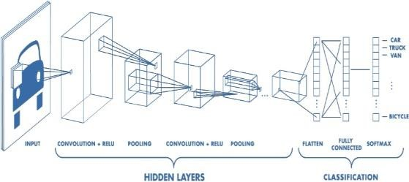

Fig-3.1.2.1 CNN

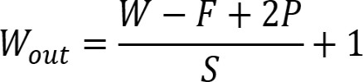

# Helmet Detection Using YOLOv5

Motorcycle riders in the divided areas are identified by their helmets using YOLOv5. When there is no helmet, the model detects this and stores it for further analysis.YOLOv5 can Identify multiple vehicles and detect whether driver is having Helmet or not as shown in Figure 3.1.3.3. **YOLOv5**

YOLOv5 is a computer vision model that belongs to the You Only Look Once (YOLO) family. YOLOv5 is a popular object detection tool. There are four primary variants of YOLOv5, each offering progressively higher accuracy rates: small (s), medium (m), large (l), and extra large (x). Additionally, the training times for each variety vary.

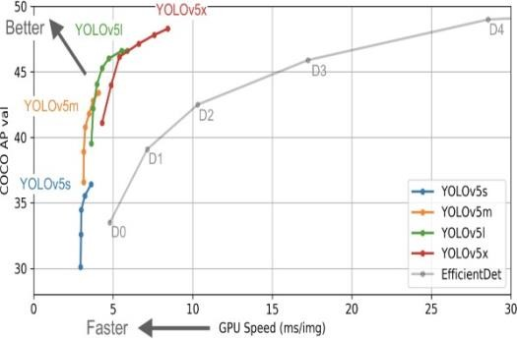

Fig:3.1.3.1 YOLOv5 Speed in Object detection.

Glenn Jocher's YOLOv3 PyTorch repository is a natural progression to the YOLOv5 repository. Developers frequently used the YOLOv3 PyTorch repository to port YOLOv3 Darknet weights to PyTorch before deploying them to production. Many people (including our Roboflow vision team) preferred the PyTorch branch's user- friendliness and would utilize it for deployment. To enable thousands of developers to train and implement their own unique object detectors that can detect

any object in the world, Ultralytics started to make research advancements in addition to repository design modifications after completely duplicating the model architecture and training process of YOLOv3.

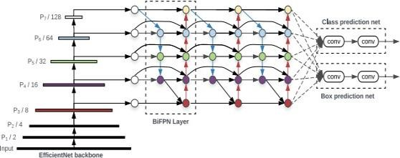

Fig-3.1.3.2 YOLOv5 Architecture.

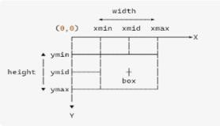

Fig-3.1.3.3 Bounding Box Calculation in YoloV5

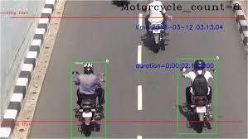

Fig-3.1.3.3 Helmet Detection Using Yolov5.

# License Plate Extraction Using OCR

To extract alphanumeric characters from the divided license plate sections, OCR techniques are used. For the purpose of identifying vehicles and recognizing license plates, extracted characters are processed.

**OCR (Optical Character Recognition)** Optical Character Recognition is referred to as OCR. It is the process that converts a text

image into a computer-readable text format. For example, if you scan an invoice or a receipt, your computer will save the scan as an image file. You cannot use a text editor to edit, search for, or count the phrases in the image file. Using OCR, the image can be converted into a text file and its contents recorded as text.The text on vehicle registration plates will be automatically recognized by the Tesseract OCR, an optical character recognition engine. Python-tesseract

Python-tesseract is an optical character recognition (OCR) tool for the Python programming language. It can thus identify and "read" text that is embedded in photos. A wrapper for Google's Tesseract-OCR Engine is called Python-tesseract. Because it can read all image formats, including jpeg, png, gif, bmp, tiff, and others, it is also utilized as a standalone script. Additionally, Python-tesseract will output the recognized text instead of writing it to a file if used as a script. It is capable of recognizing over 100 different languages.

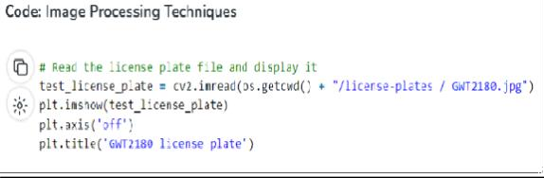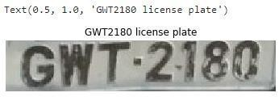

Fig-3.2.1 License-Plate Recognition using Tesseract OCR

# E-Challan Generation

An electronic e-challan is generated based on the owner information and the identified infraction. The timestamp, location, and vehicle details of the infraction are all included in the e-challan, along with the associated penalty.

Notification to Owner of the Vehicle Through electronic communication channels, the vehicle owner is informed of the traffic infraction and the issue of the e- challan. Notifications can be sent via email, mobile application, or SMS, based on the user's choices and the availability of contact information.

Instructions and Payment Options

The available payment alternatives and directions for paying the fine are included in the e-challan message. To offer the bike owner ease and flexibility, payment methods can include mobile wallets, online payment portals, or dedicated payment centers.

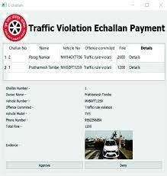

Fig:3.3.1 E-challan

# System Architecture

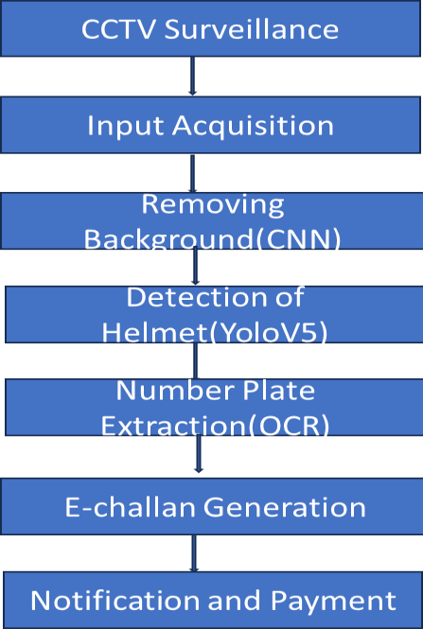

Fig:3.4.1 System Architecture

# RESULTS AND DISCUSSIONS

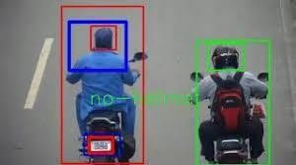

Fig:4.1 Helmet Detection

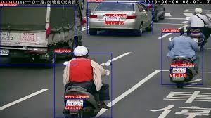

Fig:4.2 Detecting multiple Vehicles

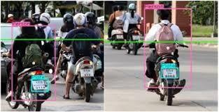

Fig:4.3 License plate Detection

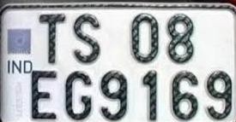

Fig:4.4 License number Extraction using OCR

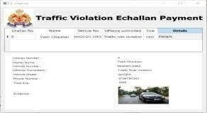

Fig:4.5 Automatic E-challan

# CONCLUSION

The suggested method uses automatic license plate identification and detection of motorcycle riders without helmets to provide a comprehensive approach to improving road safety and traffic law enforcement. The system uses cutting-edge technology like OCR for license plate identification and YOLOv5 for helmet detection to speed up the process of recognizing traffic offenses and issuing e- challans. The technology increases efficiency, decreases the need for human involvement, and encourages compliance with traffic laws by automating these functions. Convenience and transparency are further improved by the system's capacity to alert car owners of infractions and provide online payment alternatives. All things considered, the suggested strategy helps to promote safe driving conditions and efficient traffic control tactics. Road safety and adherence to traffic laws could be significantly improved with the further development and use of such systems.

# REFERENCES

1. In the 2016 IEEE International Conference on Computer and Information Technology (CIT), Nadi, 2016, P. Doungmala and K. Klubsuwan, "Helmet Wearing Detection in Thailand Using Haar Like Feature and Circle Hough Transform on Image Processing," pp. 611-614.
2. The article "Cascade Classifier based Helmet Detection using OpenCV in Image Processing" was published in May 2016 in the National Conference on Recent Trends

in Computer and Communication Technology (RTCCT 2016), by Contractorr, Dhwani, Pathak, Ketki, Sharma, Sonali, Bhagat, Shreya, and Sharma, Tanu.

1. J. Li et al., "Image processing and machine learning based safety helmet wearing detection," 2017 Ninth International Conference on Advanced Computational Intelligence (ICACI), Doha, 2017, pp. 201205.
2. "Helmet violation processing using deep learning," 2018 International Workshop on Advanced Image Technology (IWAIT), Chiang Mai, 2018, pp. 1-4, K. C.

D. Raj, A. Chairat, V. Timtong, M. N. Dailey, and M. Ekpanyapong.

1. he paper "Automatic Detector for Bikers with no Helmet using Deep Learning," presented at the 22nd International Computer Science and Engineering Conference (ICSEC) in Chiang Mai, Thailand in 2018, features a presentation by

N. Boonsirisumpun, W. Puarungroj, and P. Wairotchanaphuttha.

1. Z. Kai and W. Xiaozhi, "Wearing Safety Helmet Detection in Substation," in IEEE IIRC 2019 (Xi'an, China), 2nd International Conference on Electronics and Communication Engineering (ICECE), pp. 206-210.
2. Motorcycle detection and tracking system with occlusion segmentation," by

C.-C. Chiu, M.-Y. Ku, and H.-T. Chen, in Proceedings of the International Workshop on Image Analysis for Multimedia Interactive Services, Santorini, Greece, June 6–8, 2007, pp. 32–32.

1. "Boosting Object Proposals: From Pascal to COCO," J. Pont-Tuset and L. V. Gool, IEEE International Conference on Computer Vision (ICCV), Santiago, 2015, pp. 1546–15554.
2. "Analysis and Architecture for the deployment of Dynamic License Plate Recognition Using YOLO Darknet," by U. Upadhyay, F. Mehfuz, A. Mediratta, and A. Aijaz, in 2019 International Conference on Power Electronics, Control and Automation (ICPECA), New Delhi, India, pp. 1-6.
3. In 2018, the IEEE International Conference on Big Data was held in Seattle, Washington, USA. Rachel R. Huang, J. Pedoeem, and C. Chen presented their paper, "YOLO-LITE: A RealTime Object Detection Algorithm Optimized for Non- GPU Computers," on pages 2503-2510.
4. "You Only Look Once: Unified, realtime object detection," J. Redmon, S. Divvala, R. Girshick, and A. Farhadi, 2016 IEEE Conference on Computer Vision and Pattern Recognition (CVPR), 2016, pp. 779–788.